Guide to running the imaging lab

**General Scanco Troubleshooting**

1) Remotely shut down one of the Scanco computers

Occasionally, the Scanco HP computers will stop responding to anything and need to be shut down remotely. Try VERY hard not to just power cycle them, as they get confused and will boot for a very long time. Instead, use the command below from a PuTTy connection or from the connected and currently running Scanco station:

Set host sc####  
@decw$startup restart

Y

logout

Note that sc#### is whatever the Scanco system ID is. The VivaCT Client is SC5039, Server is SCSERV. uCT40 client is SCEVAL, server is SC4218

2) Tape drive errors

Use these commands:

show dev tp0/ful

Show dev mk/ful

Copy and paste output from PuTTy to help email sent to Scanco.

3) Computer IP addresses:

uCT40 Server: 10.21.24.204  
 uCT40 Server MP Card: 10.21.24.215

uCT Client: 10.21.24.214

uCT Client MP Card: 10.21.24.213

VivaCT Server: 10.21.24.203

VivaCT Server MP Card: 10.21.24.212

VivaCT Client: 10.21.24.202

VivaCT Client MP Card: 10.21.24.215

4) How to send a terminal:

From a DECTERM window on the machine that needs to be connected to (or through a PuTTy window connected to a machine that needs to be connected to), type:

Set disp/create/transp=tcpip/node=###.##.##.##

Create/term/deta

Note that the pound signs are whatever IP address Scanco support tells you to connect to. They have several options and will clarify.

5) Email contact: [support@scanco.ch](mailto:support@scanco.ch) (probably Daniel will respond)

6) Sales contact: [sales@scanco.ch](mailto:sales@scanco.ch) (probably Rasesh will respond)

**Repair and Quirks of Equipment**

1) X-ray cabinet

The X-ray cabinet is fond of blowing fuses. There should be several of the appropriate type available in a green pouch in a drawer near the cabinet. It will return an unable to communicate error if this happens, or if anything else happens for that matter. They’re bad at error reporting.

The Faxitron software license is tied to the wireless dongle in the back of the computer.

DXA needs the detector on spot 2 in the cabinet, X-ray on the bottom. Anytime the detector is moved it needs to be calibrated.

2) VivaCT

The monitor for the primary VivaCT computer is on the fritz. Turn it off and back on if it won’t display what’s on the computer after moving the mouse.

The computer connected to the scanner must be turned on before the satellite computer at the end of the bench

The satellite computer is connected to the tape drive for data archival

Replacing drives on the Scanco HP computers is a pain. Search by part number online to see if anything pops up, there isn’t a singular supplier.

3) MicroCT

The interlock is starting to die probably. Scanco (Sebastien specifically) is looking for a replacement.

**Computer Usernames and Passwords**

UCT-GPU-PC: UCT-GPU-PC\ microct-gpu, mousebone4!

PathVision40158: PathVision40158\200021882, mousebone4!

UCT-LARGE-DATA: UCT-LARGE-DATA\uCT-Large-Data-Set , mousebone4!

DiskTower: DiskTower\User, Mousebone4!

DESKTOP-F5DDAI5: DESKTOP-F5DDAI5\User, Mousebone4!

All uCT computers: microct, mousebone4 (regular user), system, marwees1 (admin)

GitHub: [brodtm@wustl.edu](mailto:brodtm@wustl.edu), Mousbone4!

Mathworks (for MATLAB) – [brodtm@wustl.edu](mailto:brodtm@wustl.edu), Mousebone4!

Scanco Online Help – [users@scanco.ch](mailto:users@scanco.ch), basser5dorf

**Scanner Maintenance**

1) Quality check for uCT systems

This hasn’t changed since I got here in terms of doing the scans. At some point, somehow, the contours got overwritten, so I’ve been simply copy and pasting contours from the previous QC scan to avoid pestering Scanco and then running the QC analysis task. If you want to ask them to reset it, of course, feel free.  
  
I’ve been checking the results with the CalibrationVerification software on GitHub, but uct_list can also function appropriately.

2) Database (not data, but the database information) backup:

Once per month, the database should be backed up to tape for both the uCT40 and VivaCT40. The DB backup tapes are currently placed on top of the tape drives. Once per week, the database should be backed up to disk.

3) X-ray calibration

The Faxitron must be calibrated if for any reason the detector has been moved, or if it hasn’t been calibrated in 24 hours. For DXA, the detector must be placed in drawer 2 with nothing between the detector and the source to calibrate. For X-ray, it must be on the bottom with nothing in between. If the tray is moved from 2 to the bottom or from the bottom to 2, it must be calibrated. X-ray images will have line bands across them in a grid pattern if it isn’t calibrated, and DXA will give junk data.

**Data Management**

1) uCT Data

Data must be removed from the uCT 40 roughly weekly, and from the VivaCT less frequently. Green tapes are used in the uCT40, yellow in the Viva. Green tapes hold about 800GB each, yellow 400GB. Remember that RSQ files must be present on the system to generate billing information, so be sure to run the billing information scripts (below) before removing scans.   
  
Note that running a move operation on to tape will slow the uCT40 scanner down considerably; I’ve taken to blocking off many weekends to clean data off.

2) Excess images generated for uCT

As people generate TIF images and DICOM stacks, data can start to accumulate quickly on the uCT systems. A MATLAB script under https://github.com/WashUMRC/GeneralFileManagement can be run to automatically delete all TIF images and stray DICOM images on both systems at once. Be aware that it will indeed get all of them, so make sure to run it during a down time and not while Evan is making fracture callus pictures.

3) Generating DICOM Images

DICOM stacks are of course useful and necessary for doing many of the data analysis methods we’ve come to use in the Core. There are two ways to generate DICOM images: Using Scanco’s software, and with a batch script through MATLAB.

MATLAB: <https://github.com/WashUMRC/DICOMManagement> is the location of the useful scripts. Running ctBatchDICOMFromISQ.m will generate full DICOM stacks for measurements within a range of values in a single sample number. So, if you need to generate DICOM files for all of sample 340, you can tell it to start at 00000 and end at 99999 to do all available measurements. You can of course be more specific, like 25647 to 29654 if you like. This method is preferred as it does not clog up the analysis que on the Scanco computers.

Scanco: There is a task called Convert to DICOM on each of the scanning computers. This will start a task that generates DICOM images for the volume you define, and run as an analysis the same way a cortical analysis runs. This is not the preferred way as it clogs up the analysis que and can get difficult to manage if you try to separate out multiple bones on a single measurement.

After either method: Run getDICOMFromMicro or getDICOMFromViva as appropriate and follow the prompts to gather your DICOM files. This removes the DICOM files from the Scanco disk tower and puts them where you tell MATLAB to deposit them, maintaining the measurement number structure. Note that generating and then retrieving these images will slow down the uCT40 considerably, and the VivaCT40 slightly, so try not to do this while people are scanning.

**Ordering Things**

1) Tapes for data archival

The uCT40 uses LTO4 800GB tapes (green). Order HP tapes through CDW

The VivaCT40 uses LTO3 400GB tapes (yellow). Order HP tapes through CDW

2) Airgas

Phone: 314-533-3100, extension 3

Customer Number: 1769599

PO (Aug 2018): 2935396E

**Communications**

1) Mailing address

Department of Orthopaedic Surgery

Washington University School of Medicine

660 South Euclid Ave

Campus Box 8233

St. Louis, MO 63110

2) Street Address

425 S. Euclid Ave

11th Floor

St. Louis, MO 63110

3) Fax number

314-362-0334

4) Department number (for internal billing things):

3305

5) Your desk number:

314-747-2769

6) Biomechanics number (room 11518):

314-362-8645

**Remote Connection Information**

1) PuTTy

PuTTy is key to managing Scanco’s instruments as OpenVMS often requires interaction over FTP. To install PuTTy, grab the 64 bit MSI installer here: <https://www.chiark.greenend.org.uk/~sgtatham/putty/latest.html>  
  
After installing, you’ll need to set up two distinct Saved Sessions, one using the explicit name uCT40 and one using the explicit name VivaCT40. For each, first type in the ip address of the machine in question (10.21.24.204 or 10.21.24.203), then expand Connection, expand SSH, click X11, and tick Enable X11 forwarding. Then, under SSH, click Kex, scroll through to find Diffie-Hellman group 1, click on it, and click Up to move it above the “warn below here” threshold. Next, click on Session on the tree on the left, type the appropriate name into the Saved Session field (uCT40 or VivaCT40), and click Save. Then do the same for the scanner you haven’t saved a session for yet. These get called by name by several scripts in the MATLAB library, and can be used to operate the Scanco computers remotely.

uct_evaluation – runs the evaluation software. Be aware, if you have any of the “lock” keys toggled on your keyboard, you won’t be able to draw green lines. I have no idea why either.

uct_backup – runs the backup software. Note that you won’t be able to perform functions that use the tape drive.

uct – launches the launchpad program that allows running other programs. Not usually used.

DECTERM – open another PuTTy connection and don’t launch another program.

2) Xming

Required for PuTTy to deliver graphical content. If a window doesn’t open when you try to do so in PuTTy, Xming isn’t running. Start it. If needed, download it here: <https://sourceforge.net/projects/xming/>

3) FileZilla

FileZilla is a sort-of user friendly browser-like program intended to allow remote users to interact with files on a remote machine over FTP. In this lab, it is often used to transfer single (or a few) files, like TIF images generated with the Scanco software. To connect, type the appropriate host IP, username (microct), and password (mousebone4) then hit quickconnect. You can also save a profile in the site manager tool if desired. By default, you’ll be connected to idisk1:[microct]. This is not a useful folder. We typically have people save TIF images to the scratch folder, at idisk1:[microct.scratch]. Sometimes, you’ll need to access a given measurement folder to look at files placed there, such as task execution logs. Those files are located at dk0:[microct.data.samplenumber.measurementnumber].

When transferring data from the remote machine, make sure that Transfer -> transfer type is set to Ascii for text files or Binary for anything else. Data can be copied over by drag and dropping, or by rightclicking and selecting Download (note which folder is selected in the download pane on the left).

4) Box

Currently Box is being used as the archival location of data after it has been processed as a service from the Core. However, it sucks. It can’t handle files larger than 15GB and the web interface is straight garbage for anything larger than a Word document. To work with it, you’ll have to use FileZilla to connect over FTP. In 2018.

To deal with this, you’ll have to create a site in FileZilla’s Site Manager (call it whatever you’d like, though Box Wustl works well). Note that it still won’t handle single files larger than 15GB because it’s still 2004 in their world. If you try to upload a set of DICOM files as loose files, it will take an excruciatingly long time as it must initiate a connection for each file. To get around this sad limitation, the best thing to do is to use 7-zip to create a set of compressed files limited to ~8GB in size and then upload those. The settings to use in 7-zip are in the image below:

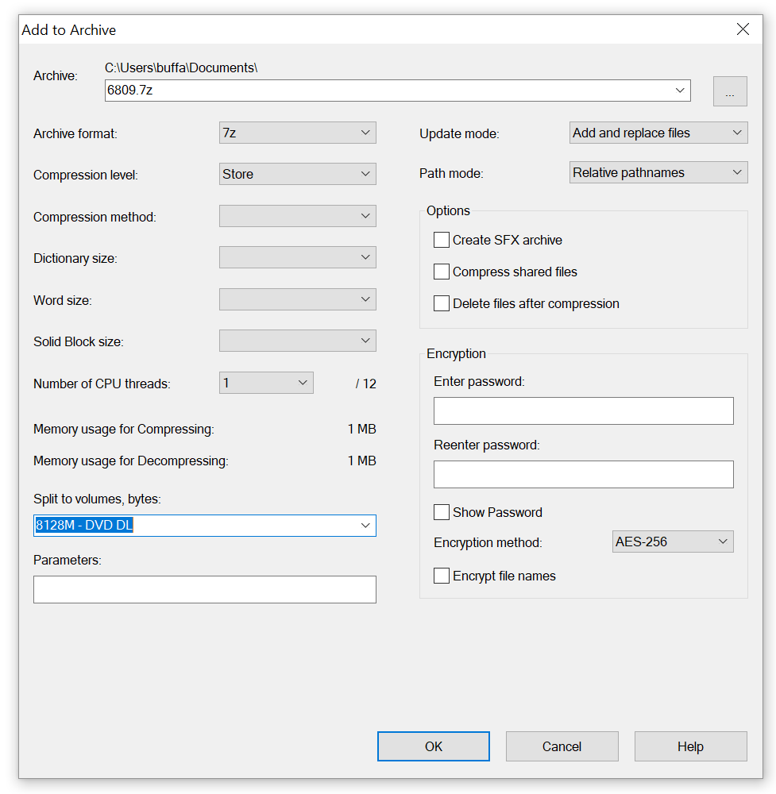

To connect via FileZilla:

The Host field should be [ftp.box.com](ftp://ftp.box.com)

Protocol: FTP (default)

Encryption: Explicit FTP over TLS (default)

Logon Type: Account

User: Wustl Key

Password: Wustl key password

Account: Any name (DanBox is a decent example)